Attendance Tracker Program

User guide

Written by: Clifford Dela Cruz

Contents

Parts of Attendance Tracker program: 3

1. Search 3

2. Generate report 8

3. Extract Person’s Data 9

4. Scan QR code 10

# Parts of Attendance Tracker program:

1. Search – This is to search the name of an attendee

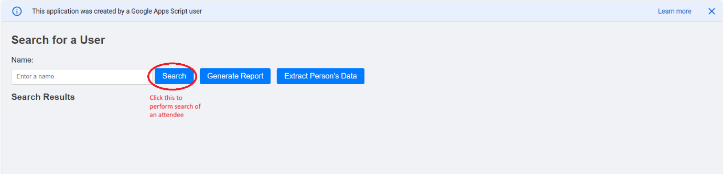

1a. **If entered name could not be found**, it will prompt user to register the attendee.

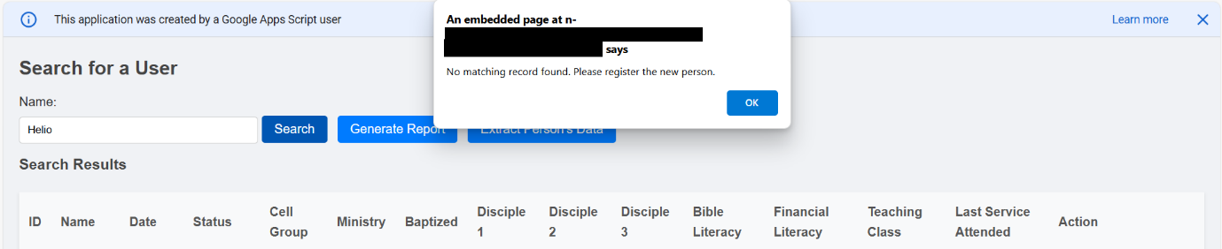

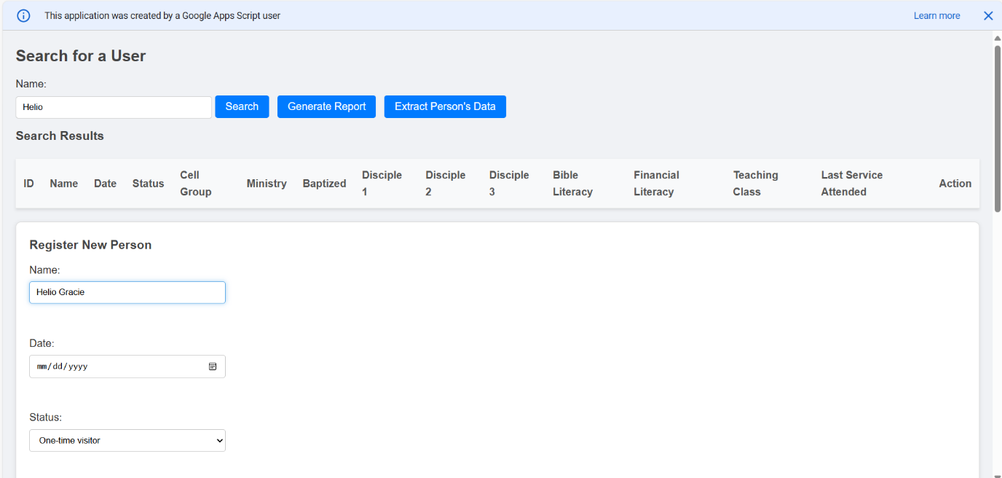

A closer look at **Register New Person** screen

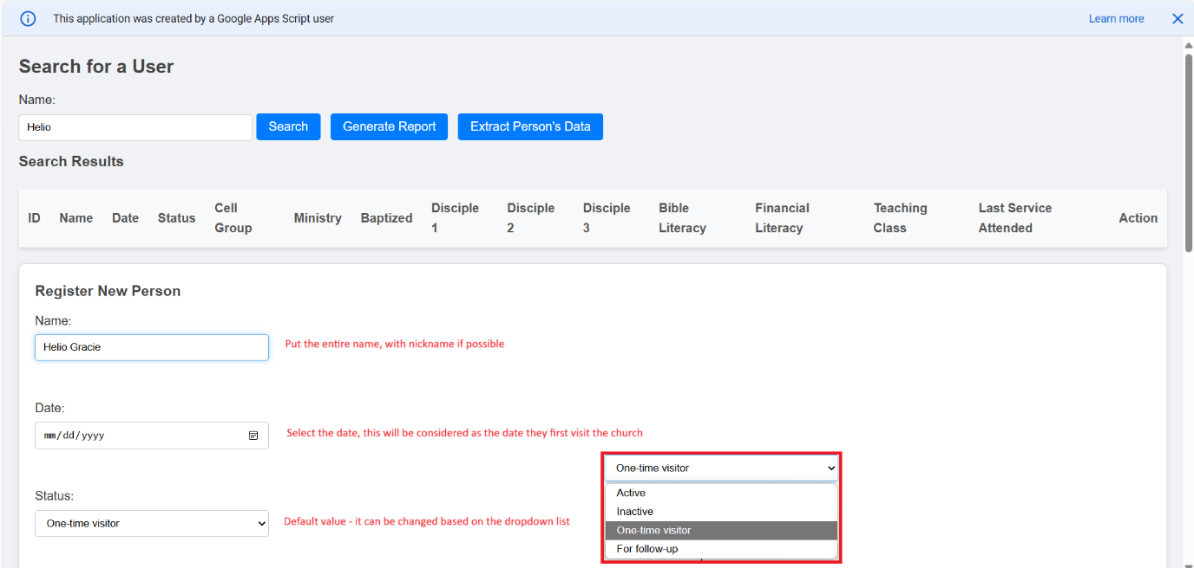

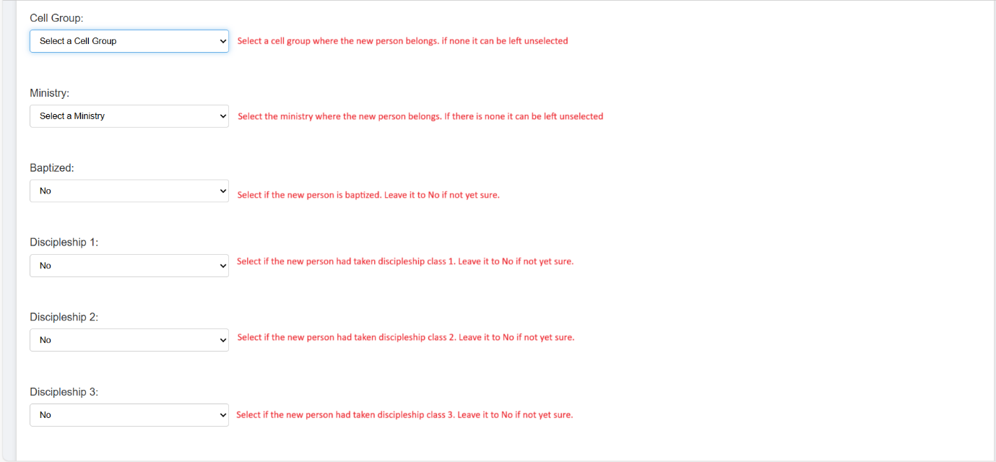

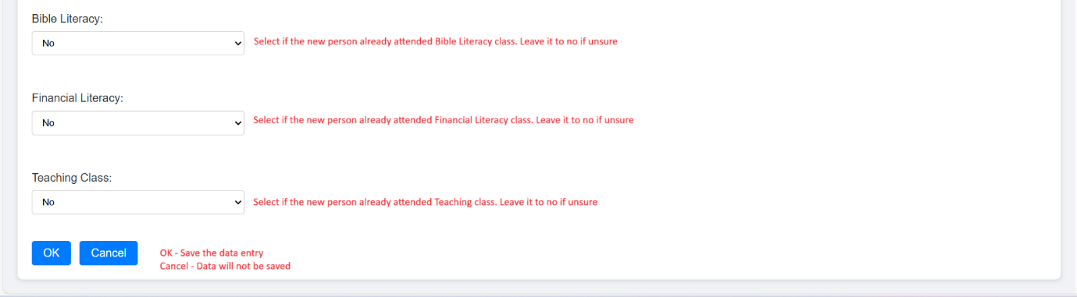

A pop-up message will display that the data entry is saved

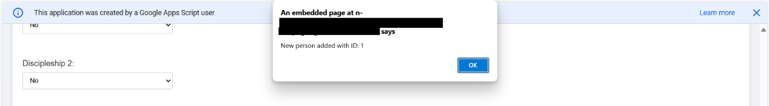

Data is saved in google spreadsheet under ‘**Person_Master**’ worksheet

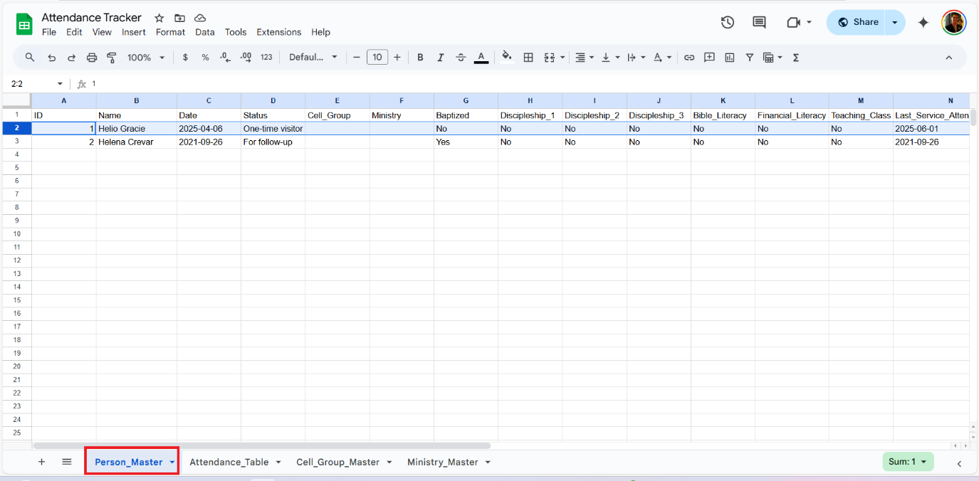

1b. **If entered name is found**, it will display the names based on the entered value in the search field

**Mark Attendance** will allow user to mark the attendance of the person.

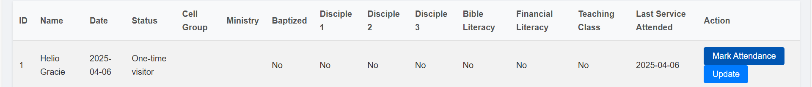

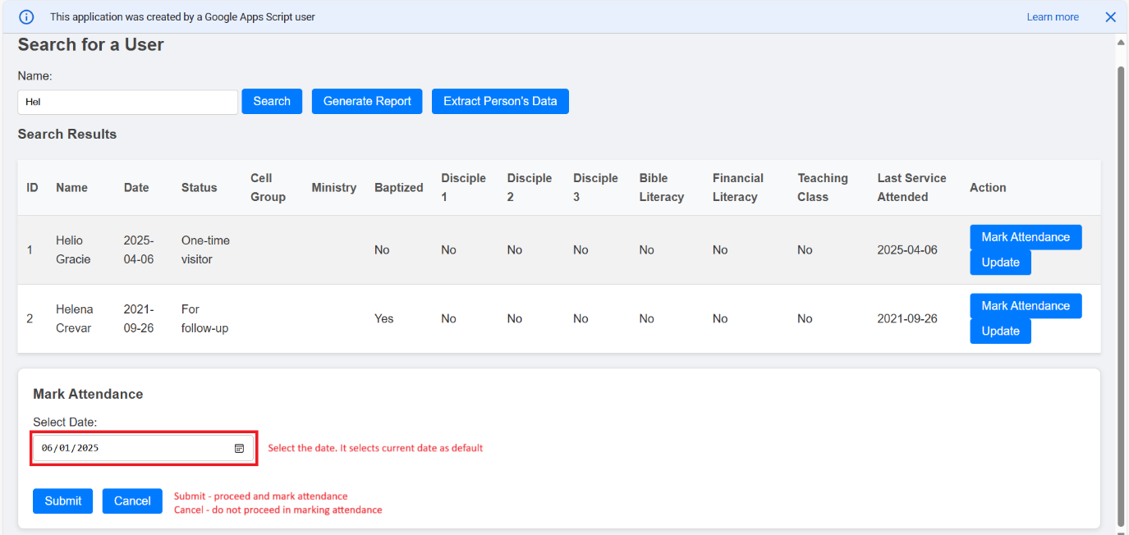

A pop-up message will be displayed to inform user that the attendance is marked.

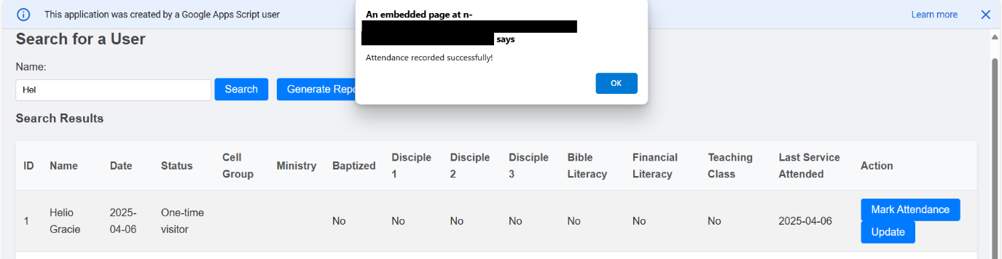

Data will be saved in google spreadsheet under ‘**Attendance_Table**’ worksheet

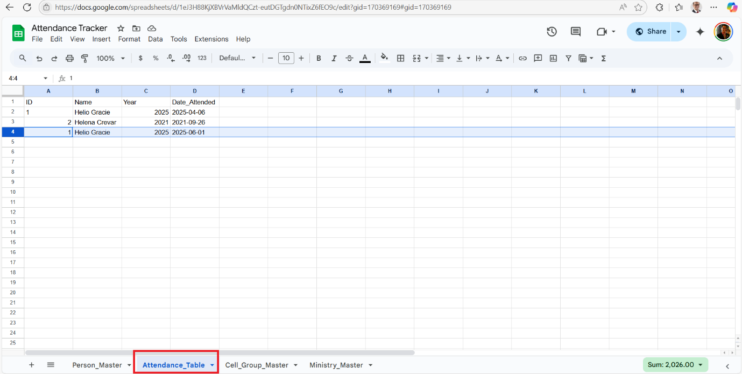

**Update** will allow user to update the details of the user

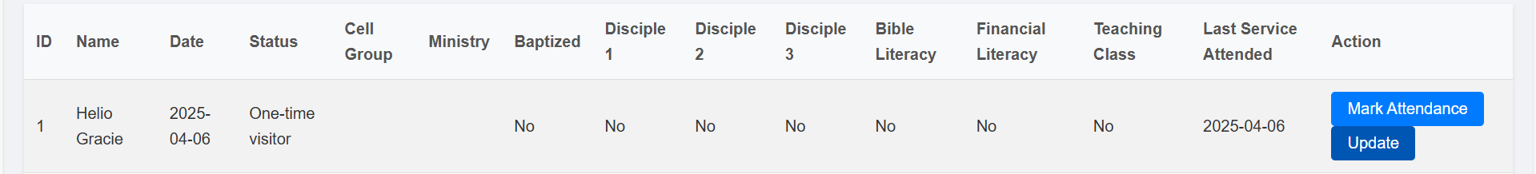

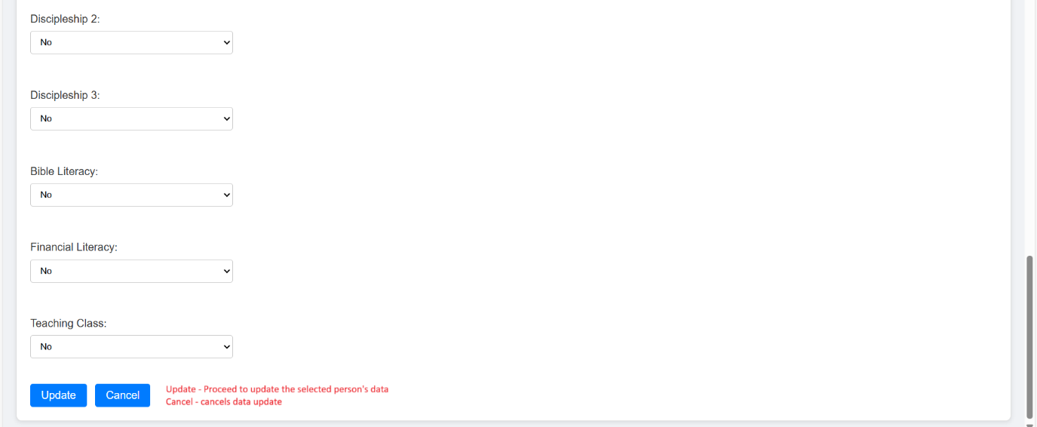

A pop-up message will be displayed to inform the user that the update is successful.

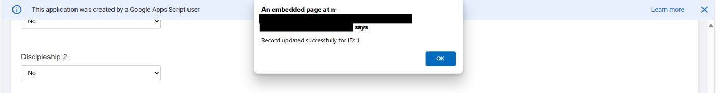

The selected person’s data will be updated in the google spreadsheet under ‘**Person_Master**’ worksheet. (In this example, status changed to ‘**Active’**)

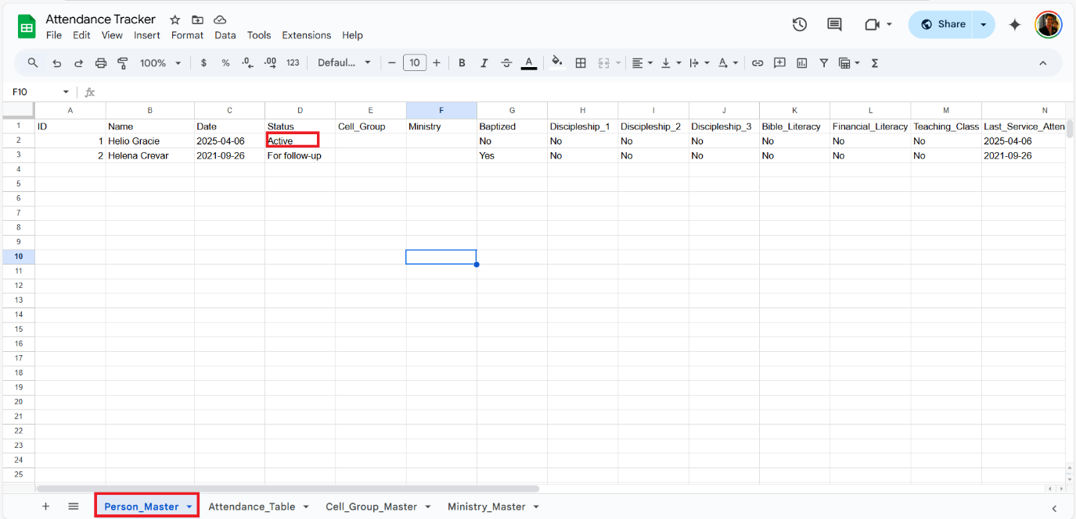

1. Generate report allows us to download the data from Attendance_Table to acquire the information of member’s attendance.

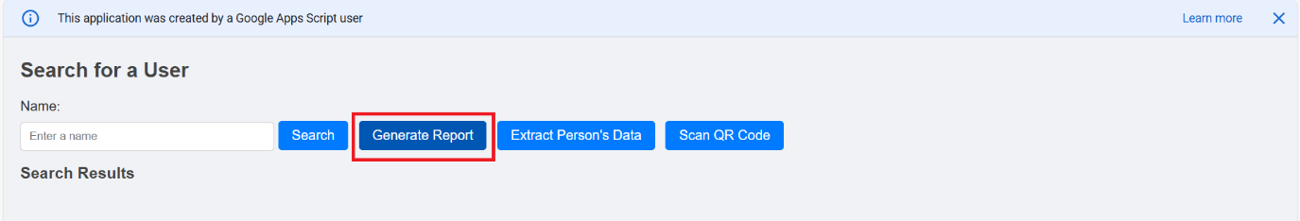

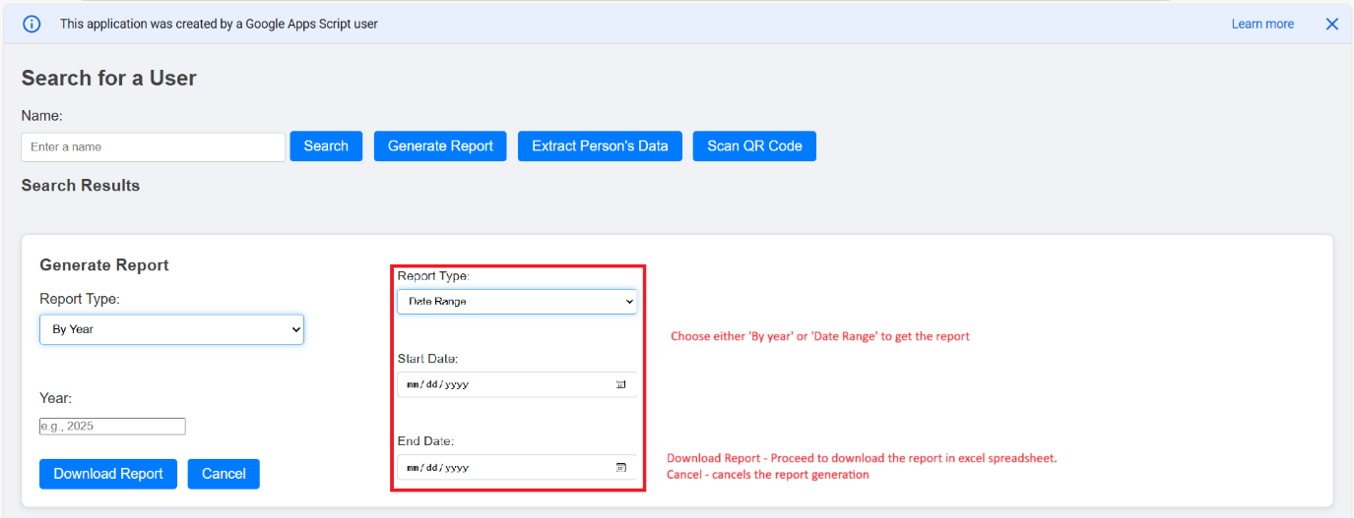

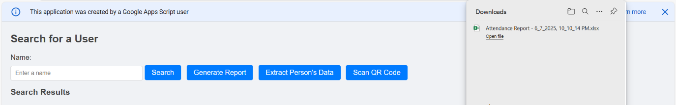

1. Extract Person’s Data will download the list of members. This will be useful to determine if a member requires to be followed up.

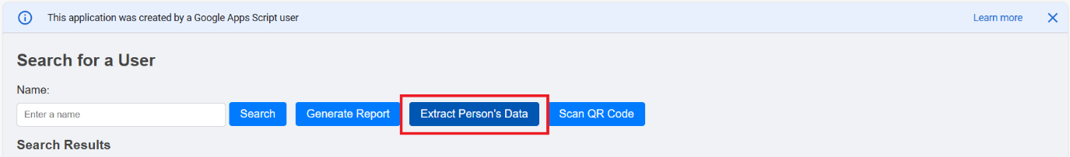

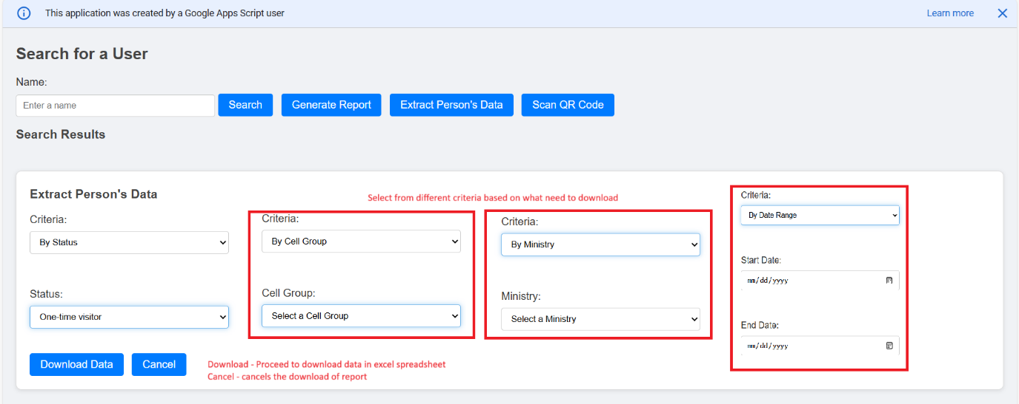

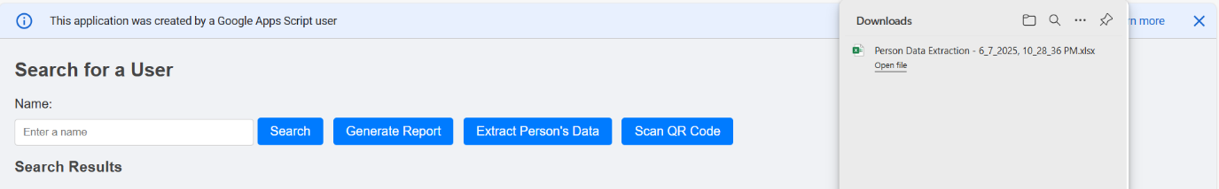

1. Scan QR code (applicable in mobile phone) to be able to scan a QR code of a member so it is easier to get the name instead of typing it.

Example: from QR code generated from qrcode-monkey.com

